**A Mini Project Synopsis on**

“An efficient Flood Identification and

Cautioning System”

Submitted

In partial fulfilment of the requirement for the VI Semester of Bachelor of Technology in Computer Science and Engineering of the academic year 2019-2020

**Submitted By**

**KOLHAPURAM SHREYADA R17CS194**

**LALUPRASAD M R17CS205**

**MANASA.C.H R17CS221**

**RESHAM SUNDAR KUMAR R17CS241**

**Mini Project Group ID: GROUP D1**

**Section: D**

**Under the guidance of:**

Prof. Vinay Kumar

Assistant Professor

School of C & IT, REVA University

**REVA UNIVERSITY**

School of Computing and Information Technology

Bengaluru-560064

2019-20

**ABSTRACT**

Internet of things (IoT) is a technology that connects anything and everything over the Internet. IoT is the newest technology rapidly widening in its usage. This technology brings new products such as disaster monitoring.The technology has led to improvements in terms of communication and information. Internet of Things Technology (IoTs) has greatly influenced the development of early warning information systems whereas machine learning (ML) methods contributed highly in the advancement of prediction systems providing better performance and cost-effective solutions. Flood is an unavoidable natural disaster, causing heavy flow of traffic and can also cause severe damage to properties and lives. For this reason, we created a flood detection system to monitor rising water in various areas and a prediction system where we collect datasets to predict the flood affected area or occurrence of flood . Using ultrasonic sensor we created flood level sensing device which is attached to Arduino UNO controller to process the sensor’s analog signal into a usable digital value of distance. Flood height is determined by subtracting the sensor’s height with respect to the floor minus the sensed distance between the sensor and the flood water. Updates on the height of the water level will be updated on the website to alert the authorities.This project aims to realize the security requirements and security architecture of Internet of Things technology for flood identification and cautioning and discusses the demand and overall design of flood management.

**INTRODUCTION**

Flood occurs when water overflows from the river, lake or from heavy rainfall and it can happen at any time of the year. Flood is one of the disasters that often occur due to extreme weather. The main cause of flooding is not only influenced by the weather but also the human activities that damage the environment.Flooding can be very dangerous, when floods happen in an area that people live, the water carries along objects like houses, cars, furniture and even people. It can wipe away property, trees and many more heavy items.

‘An efficient Flood Identification and Cautioning System ’ is an intelligent system which keeps close watch over various natural factors to predict a flood, so we can embrace ourselves for caution, to minimise the damage caused by the flood. Natural disasters like flood can be devastating leading to property damage and loss of lives. To eliminate or lessen the impacts of the flood, the system uses various natural factors to detect flood. The system has a wifi connectivity, thus it’s collected data can be accessed from anywhere quite easily using IoT and various datasets to predict the area affected due to flood using machine learning models.

Through the local government unit flood control has been extending their efforts to inform the commuters regarding the situation in flooded areas during the rainy season, the dissemination of information to the locals are not enough. To avoid destruction of nature and mankind it is needed to anticipate the upcoming flood .For this reason, the ‘An efficient Flood Identification and Cautioning System’ has been developed, to help the user to avoid floods and its related problems.

When a flood occurs, the ultrasonic sensor will send a signal to the microprocessor circuit and the sense water level will be displayed in the user interface and it will automatically send an alert in the website and will continue to update until the water level detected returns to normal. The process repeats as the water level continues to rise.

**Arduino Uno**

This is the new Arduino Uno R3. Not withstanding every one of the highlights of the past board, the Uno now utilizes an ATmega16U2 rather than the 8U2 found on the Uno (or the FTDI found on past ages). This takes into account speedier exchange rates and more memory. No drivers required for Linux or Mac (inf petition for Windows is required and incorporated into the Arduino IDE), and the capacity to have the Uno appear as a console, mouse, joystick, and so on.

Arduino is an open-source physical figuring stage in view of a basic I/o board and an advancement domain that actualizes the Processing/Wiring dialect. Arduino can be utilized to create remain solitary intuitive questions or can be associated with software on your computer (e.g. Streak, Processing, MaxMSP). The open-source IDE can be downloaded for nothing (at present for Mac OS X, Windows, and Linux).

The Uno R3 likewise includes SDA and SCL pins alongside the AREF. What's more, there are two new pins set close to the RESET pin. One is the IOREF that enable the shields to adapt to the voltage provided from the board. The other is a not associated and is held for future purposes. The Uno R3 works with every single existing shield however can adjust to new shields which utilize these extra pins.

**Temperature and Humidity Sensor**

# The Temperature and Humidity sensor used is DHT11 Digital Temperature Humidity Sensor Module consists of resistive humidity detection components and ntc temperature testing The perfect computerized temperature sensing sensor module is associated with 8-byte mcu The perusing made by DHT11 is extremely compact and stable; however, the client needs to refresh the perusing of the sensor in each 2 sec with a specific end goal to stay away from past signal gathering of information. Inferable from its little size DHT11 devours low power, typically 3-5.5 volt control is utilized for the working of the sensor and up-to-20 meter flag transmission makes this gadget appropriate and mainstream for different applications. The sensor is versatile and very steady, can be utilized for embedded gadgets for weather observing and similar kinds of utilizations. Single information line is utilized for recovering the estimation made by the sensor.

**WiFi module**

ESP8266 WiFi Module is an integrated TCP/IP protocol stack with an independent SOC with that can give any microcontroller access to your WiFi network.

The chip at first grabbed the attention of western makers in August 2014 with the ESP-01 module, made by a third-party manufacturer, Ai-Thinker.

Each ESP8266 module comes pre-customized with an AT command set firmware, which means, you can basically attach this to your Arduino gadget and get about as much WiFi-ability as a WiFi Shield offers (and that is simply out of the case)! The ESP8266 module is a to a great degree savvy board with a tremendous, and consistently developing, group.

This module has a sufficiently effective on-load up preparing and storage capability that enables it to be integrated with the sensors and other application particular devices through its GPIOs with insignificant improvement in advance and negligible loading during runtime. Its high level of on-chip coordination takes into consideration negligible outer hardware, including the front-end module, is intended to involve insignificant PCB territory. The ESP8266 underpins APSD for VoIP applications and Bluetooth coexistence interfaces, it contains a self-aligned RF enabling it to work under every single working condition, and requires no outside RF parts.

**Ultrasonic sensor**

**The HCSR04** measures object distance using ultrasonic ranging. It offers incredible range accuracy and stable readings in a simple to-use bundle. It 's working isn 't influenced by daylight or dark material like sharp range discoverers are (delicate materials like fabric can be hard to distinguish).

The fundamental basic principle of operation is beneath, use IO port TRIG to trigger running. It needs 10 us abnormal state signal in any event module will send eight 40kHz square waves automatically and will test if there is any signal returned. In the event that there is signal returned, yield will be abnormal state signal through IO port ECHO. The span of the abnormal state signal is the time from transmitter to getting with the ultrasonic.

Testing separation = length of abnormal state x sound velocity(340m/s)/2 .

You can use the above figuring to discover the separation between the impediment and the ultrasonic module.

**Water Flow sensor**

# Water Flow Sensor / Fluid FLowmeter Control Switch YF-S201-Water flow sensor may be utilized to assess the flow of liquids, i.e. the usage of fluids in domestic or industrial use. By way of instance, you may earn a custom cocktail dispensing machine, may also use this sensor to accurately quantify components like Soda, Water, etc.. Water flow sensor is made up of plastic valve system, a water rotor, plus a hall-effect detector. Its rate varies with another speed of flow. The hall-effect sensor outputs the corresponding heartbeat.

**Water Level sensor**

Level sensors are used to detect the level of substances that can flow. Such substances include liquids, slurries, granular materials and powders. Level measurements can be done inside containers or it can be the level of a river or lake. Such measurements can be used to determine the amount of materials within a closed container or the flow of water in open channels.

**MOTIVATION**

India witnesses flood due to excessive rain which then results in overflow of rivers, lakes and dams, which adds to cause large amounts of damage to people's lives and property. In the past, India has witnessed many of the largest, most catastrophic floods, causing irreparable damage to people's livelihood, property and crucial infrastructure**.In October 1943, Chennai** saw the worst flood that hit the city. Flood occurred due to excessive rains that lasted for 6 days and overflowed Coovum and the Adyar rivers. Exact figure of loss of lives is unknown, but it is estimated between 1800 and 2500 people.

**June 2013 North Indian floods.**Heavy rain due to a cloudburst caused severe floods and landslides on the North Indian states, mainly  Uttarakhand and nearby states. More than 5,700 people were presumed dead. the Indian state of Uttarakhand and adjoining areas received heavy rainfall, which was about 375% more than the benchmark rainfall during a normal monsoon. This caused the melting of Chorabari Glacier at the height of 3800 metres, and eruption of the Mandakini River.which led to heavy floods in Gobind ghat, KedarDome, Rudraprayag, Uttrakhand, Himachal pradesh and western Nepal. People in these areas were severely affected there was a huge loss of both property and mankind. This motivated us to work on a solution to anticipate occurrence of floods estimate its intensity inform the concerned authorities and help them take action to prevent floods.

**LITERATURE SURVEY**

Flood Control Operation Mode with forecast information (FCOMFI) is an important base for risk analysis of the reservoirs DIAO YanFang& WANG BenDe have analyzed the four uncertainties that is hydraulic, hydrological, stage-storage uncertainty and time-delay uncertainty, and also their probability distributions.The major potential risks are included in two methods i. Risk of reservoir ii. Risk of lower reach. The risk analysis of FCOMFI aims at the safety of the reservoir and the effective utilization of the flood water resources.

Flood control, which may be equally important in semi-arid areas, correspond to two different reservoir water levels. The first is the limited water level it can be used for flood control. There are two approaches are proposed by Ruan Yun, Vijay P. Singh ,one is multiple duration limited water level and second is dynamic limited water level. This paper also proposed a dynamic limited water level for flood control build on conditional probabilities of large storms. This means that the annual limited water level for the flood season can be modified by the several multiple duration limited water levels such as monthly duration limited water levels or weekly duration limited water levels.

**Application of Internet of Things in Flooding Prevention Management System**

The Survey has analyzed the security architecture and security requirements of IOT technology. The paper describes the demand of urban waterlogging prevention management system with the help of IOT.

**Urban flooding in recent decades in four mega cities of India**

People are migrating from rural to urban areas due to unemployment and other reasons. The population count is increasing day by day and due to that cities are facing many new challenges. Flooding condition is one of the big challenges increased due to uncontrolled growth of mega cities. The article describes the population count and death rate due to flooding in four mega cities in India.

**OBJECTIVES**

1. Detection of flood - This flood alert system is basically useful to get an idea about flood in forecast to do the sensing of the incoming water level for detection of flood is done by implementing sensors.
2. Avoiding the occurrence of flood - In this way water level will be sensed by the sensor and an alert message will be given to the authorities who will take further action on that command.

**SYSTEM REQUIREMENTS**

|  |  |
| --- | --- |
| **Software Requirements** | **Hardware Requirements** |
| * IOT Gecko | * Temperature Humidity Sensor |
| * Arduino Compiler | * Arduino Uno |
| * MC Programming Language: C | * Wifi Module |
| * Python IDLE | * Ultrasonic Sensor |
| * Anaconda Navigator | * Water Flow Sensor |
|  | * Water Level Sensor |
|  | * LCD Display |
|  | * Resistors |
|  | * Capacitors * Transistors * Cables and Connectors * Diodes * PCB and Breadboards * LED * Transformer/Adapter * Push Buttons * Switch * IC * IC Sockets |

**EXPECTED IMPLEMENTATION METHOD**

To detect a flood the system observes various natural factors, which includes humidity, temperature, water level and flow level. To collect data of mentioned natural factors the system consist of different sensors which collects data for individual parameters. For detecting changes in humidity and temperature the system has a DHT11 Digital Temperature Humidity Sensor. It is an advanced sensor module which consists of resistive humidity and temperature detection components.The water level is always under observation by a float sensor, which works by opening and closing circuits as water levels rise and fall. It normally rests in the closed position, meaning the circuit is incomplete and no electricity is passing through the wires yet. Once the water level drops below a predetermined point, the circuit completes itself and sends electricity through the completed circuit to trigger an alarm. The flow sensor on the system keeps an eye on the flow of water. The water flow sensor consists of a plastic valve body, a water rotor, and a hall-effect sensor. When water flows through the rotor, rotor rolls. Its speed changes with different rate of flow.The system also consists of a HC-SR04 Ultrasonic Range Finder Distance Sensor. The Ultrasonic sensor works on the principle of SONAR and is designed to measure the distance using ultrasonic waves to determine the distance of an object from the sensor. All the sensors are connected to Arduino UNO, which processes and saves data. The system has wifi feature, which is useful to access the system and its data over IoT.Further, floods can be predicted using various Machine Learning models and datasets using Python Libraries.

**Block Diagram:**

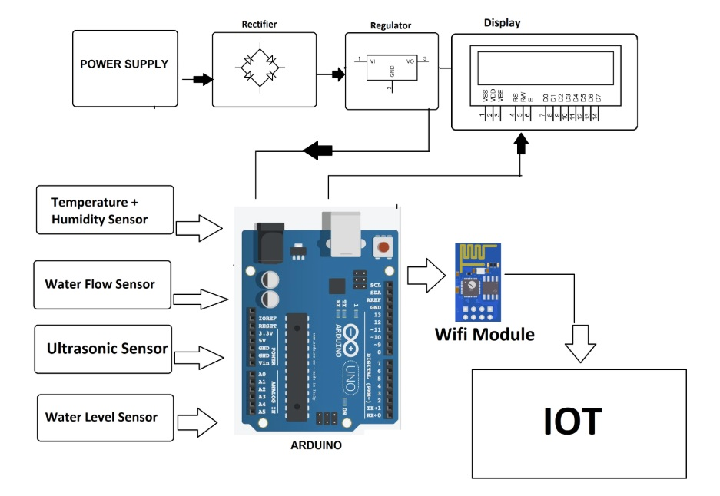

**EXPECTED NEW APPLICATIONS**

1. Disaster flood alert system using Wi-fi and ultrasonic Range Finder Distance sensors is one of the important technology which is useful to make the people alert from disaster flood.
2. Most of the water bodies are very easily accessible to common people.At times it may happen,the weather conditions change suddenly and the season may become violent and sometimes it may result in flooding and lives can be lost in the process.
3. So we have developed a system to detect the changes in weather and water-level so as to alert the authorities.Following this an alarm can be raised and people can be escorted to safety.
4. The system constantly keeps checking the weather condition and updates the data over IOT.
5. In case the parameters reach dangerous levels,the system raises an alarm thereby alerting the authorities.
6. The onboard buzzer sounds an alarm whereas the authorities are alerted remotely by a tone sequence and an alert message..
7. A prototype of the proposed system is discussed in this paper and the results of the testing phase is also elaborated. The architecture of the system can be expanded further to a fully functioning system in alerting the public of an impending disaster caused by flood.
8. With that, necessary preparations and safety measures can be done. It could be a help to prevent or lessen the damages that flood may bring.
9. Further,flood prediction can be done using ML datasets and the area affected due to floods can also be calculated correspondingly.

**CONCLUSION**

According to definitions of IOT, if we consider a sensor as an element of IOT which enables to communicate its current status and be published on Internet, then our proposal is very close to what we are intending to achieve within the concept of Internet of things.

Nevertheless, the real intent of the proposal is to achieve a flood identification and cautioning system.

The device prototype achieves the objective of this project by having the following abilities, such as: the system is able to conduct and record the data frequently and post it into a website by receiving sensed data from the sensors.

It is concluded that this system will be useful as one of the solutions that could be implemented in order to reduce the number of flood casualties that might happen in the near future. It is hoped that the proposed architecture can be further developed into a functioning system which could be beneficial to the community.

**REFERENCES**

[1]S. Azid, B. Sharma, K. Raghuwaiya, A. Chand, S. Prasad, and A Jacquier, “SMS Based Flood Monitoring and Early Warning Systems,” ARPN J. Eng. Appl. Sci., vol. 10, no. Vol. 10, No.15, pp. 6387–6391, 2015.

[2] Kalpesh R. Dashpute,.Nilesh S. bawa, Vishal B. Gaikwad, Sagar S. Sawkar, “FLOOD DETECTION USING IOT '' IJARIIE-ISSN(O)-2395-4396,Vol-4 Issue-2 2018.

[3] D. Satria, S. Yana, R. Munadi, S. Syahreza,Prototype of Google Maps-Based Flood MonitoringSystem Using Arduino and GSM Module, Int. Res.J. Eng. Technol., 4, 10, 1044–1047 (2017)